Ohio Staff Council of Higher Education  c/o Michael Hicks  Columbus State Community College  550 E. Spring Street  Columbus, OH 43215  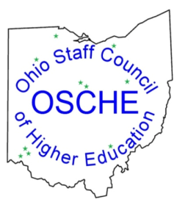  Phone (614) 287-2883 Fax (614) 287-6026 | INVOICE
 | Date: March 6, 2019

To:  OSCHE Member School | For:  Annual OSCHE Membership Dues for FY19/20  www.ohiostaffcouncil.org

DESCRIPTION | AMOUNT
$250 Annual Membership Dues (for FY19/20) to include:

--Participation in and information from OSCHE Quarterly Meetings.

--One paid registration for the Annual OSCHE Summer Conference.

--Access to all parts of the OSCHE Web site including posting comments in the blog section.

--Unlimited use of the OSCHE listserv to determine what other schools are doing regarding specific issues.

--Access to the OSCHE Matrix with important data from each participating institution.

--Voting rights at OSCHE meetings.

TOTAL | $250.00

Make all checks payable to: Ohio Staff Council of Higher Education
Prompt payment is appreciated.
If you have any questions concerning this invoice, contact Michael Hicks, OSCHE Treasurer at (614) 287 – 2883 or mhicks25@cscc.edu.

Thank you!

