Ohio Staff Council of Higher Education  c/o Michael Hicks  Columbus State Community College  550 E. Spring Street  Columbus, OH 43215  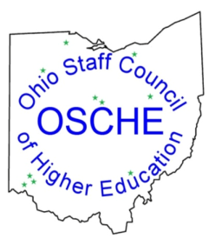  Phone (614) 287-2883 Fax (614) 287-6026 | TRAVEL REIMBURSEMENT
 | Date: February 28, 2019

Name:
Membership Institution:
Mailing Address:
Check made payable to:
Business/Travel purpose:
Travel Date(s):

COMMERCIAL TRANSPORTATION
MILEAGE RATE @ $ .58 per mile
Travel Destination (From/To)
DATE MILES TOTAL
FROM: | TO:
FROM: | TO:
FROM: | TO:
FROM: | TO:
 |  | TOTAL REIMBURSEABLE |  | $

APPROVED: ____________________________________________ Date _____________________
(Authorized Approver – OSCHE Officer)

Please submit completed travel reimbursement form with any receipts (if applicable)to:

Ohio Staff Council of Higher Education
c/o Michael Hicks
Columbus State Community College
550 E. Spring Street
Columbus, OH 43215

If you have any questions concerning this form, contact Michael Hicks, OSCHE Treasurer at (614) 287 – 2883 or mhicks25@cscc.edu.

Thank you!

